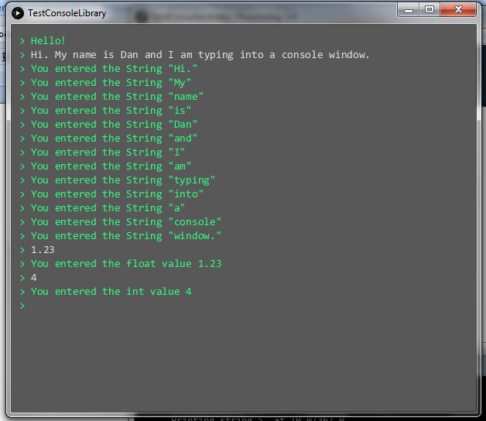

import processingconsole.*;

Console terminal;

Scanner scanner;

void **setup**()

{

  terminal = new Console( this, "doIt" );

  terminal.termprintln( "Hello!" );

}

void **draw**()

{

}

public void doIt()

{

  scanner = terminal.getScanner();

  println( "doIt: starting: scanner = " + scanner );

  boolean done = false;

  while( !done )

  {

    if( scanner.hasNext() )

    {

      if( scanner.hasNextInt() )

      {

        int nextInt = scanner.nextInt();

        println( "Received nextInt = " + nextInt );

        terminal.termprintln( "You entered the int value " + nextInt );

      }

      else if( scanner.hasNextFloat() )

      {

        float nextFloat = scanner.nextFloat();

        println( "Received nextFloat = " + nextFloat );

        terminal.termprintln( "You entered the float value " + nextFloat );

      }

      else

      {

        String nextString = scanner.next();

        println( "Received nextString = " + nextString );

        terminal.termprintln(

"You entered the String \"" + nextString + "\"" );

      }

    }

  }

}

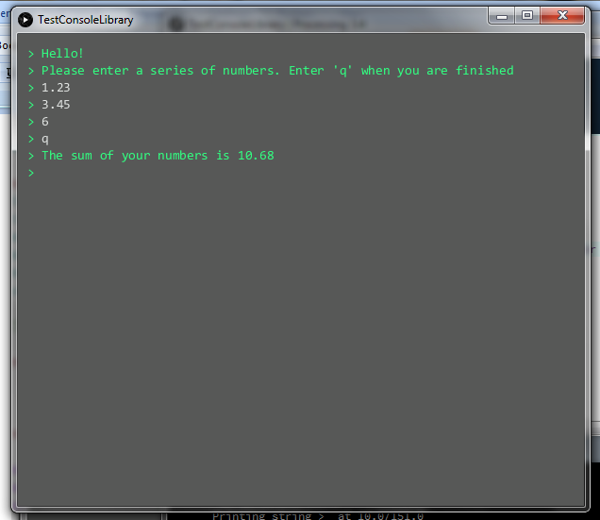

import processingconsole.*;

Console terminal;

Scanner scanner;

void **setup**()

{

  terminal = new Console( this, "sumIt" );

  terminal.termprintln( "Hello!" );

}

void **draw**()

{

}

public void sumIt()

{

  terminal.termprintln(

"Please enter a series of numbers. Enter 'q'when you are finished" );

  scanner = terminal.getScanner();

  boolean done = false;

  float sum = 0.0;

  while( !done )

  {

    if( scanner.hasNext() )

    {

      if( scanner.hasNextFloat() )

      {

        sum += scanner.nextFloat();

      }

      else

      {

        String nextWord = scanner.next();

        if( "q".equalsIgnoreCase( nextWord ) )

        {

          done = true;

        }

        else

        {

          terminal.termprintln( "The value " + nextWord + " is not legal." );

          terminal.termprintln(

"Please enter a number or the letter 'q' when you are done" );

        }

      }

    }

  }

  terminal.termprintln( "The sum of your numbers is " + sum );

}

**Building the library from the command line**

...\ConsoleLibrary\classes>cd ..\src\processingconsole

...\ConsoleLibrary\src\processingconsole>"c:\Program Files\Java\jdk1.8.0_144\bin"\javac

-source 1.6 -target 1.6 -d ..\..\classes

-classpath ..\..\..\processing-3.4-windows64\processing-3.4\core\library\core.jar *.java

warning: [options] bootstrap class path not set in conjunction with -source 1.6

1 warning

...\ConsoleLibrary\src\processingconsole>cd ..\..\classes

...\ConsoleLibrary\classes>"c:\Program Files\Java\jdk1.8.0_144"\bin\jar

-cvf ..\bin\processingconsole.jar processingconsole

added manifest

adding: processingconsole/(in = 0) (out= 0)(stored 0%)

adding: processingconsole/Console$1.class(in = 1829) (out= 850)(deflated 53%)

adding: processingconsole/Console$StringDescriptor.class(in = 653) (out= 377)(de

flated 42%)

adding: processingconsole/Console.class(in = 5824) (out= 3035)(deflated 47%)

adding: processingconsole/Scanner.class(in = 3600) (out= 1846)(deflated 48%)

...\ConsoleLibrary\classes>copy ..\bin\processingconsole.jar ..\processingconsole\library

Overwrite ..\processingconsole\library\processingconsole.jar? (Yes/No/All): yes

1 file(s) copied.